A2 – Encryption Standards

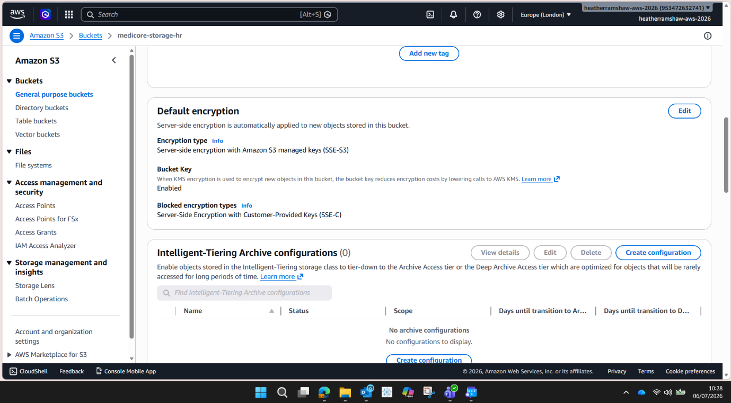

Amazon S3 was configured with Server-Side encryption using Amazon S3 Managed Keys (SSE-S3). This applies AES-256 encryption to all objects stored within the bucket, ensuring data is encrypted at rest.

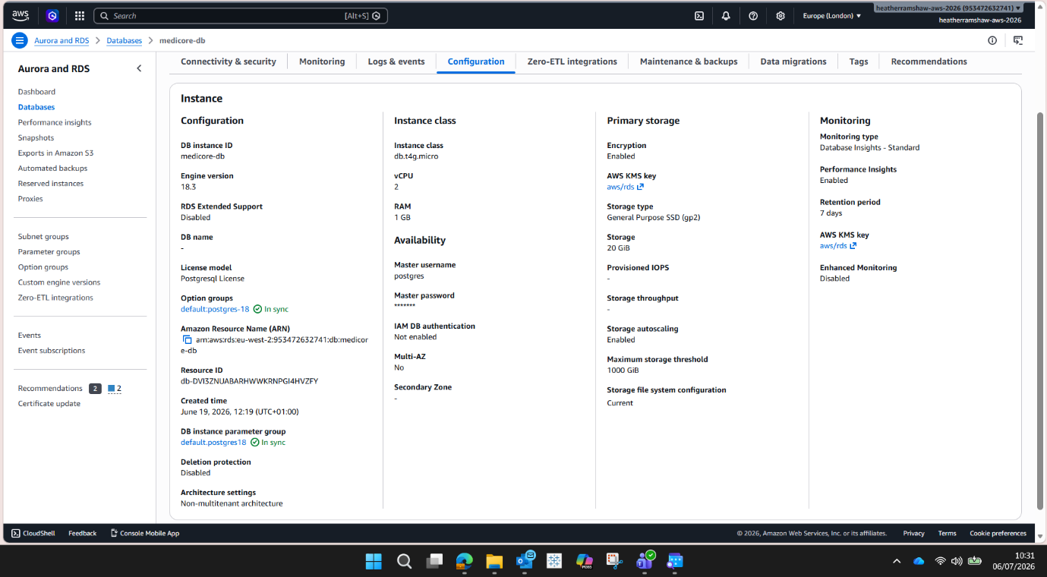

Amazon RDS PostgreSQL was configured with encryption enabled using AWS Key Management Service (KMS). This provides AES-256 encryption at rest for the database storage and automated backups, helping to protect sensitive NHS patient data.

Service | Encryption Standard | Purpose
Amazon S3 | SSE-S3 (AES-256) | Encrypts files and backups at rest
Amazon RDS PostgreSQL | AWS KMS (AES-256) | Encrypts database storage and backups
Web Application | HTTPS/TLS | Encrypts data in transit between users and application

